Clinical and Translational Research Unit (CTRU)
UGA Health Sciences Campus
109 Bowstrom Road
Athens, GA 30606

Driving directions:

From the UGA main campus:

Main entrance: Head north from campus until you reach Prince Ave., then turn left onto Prince. After approximately 1.5 miles, turn left again from Prince Ave. onto Bowstrom Road (easy to miss- recommend using GPS). Follow this road until you reach a parking lot, which is shared by the Childcare Center and the CTRU (the CTRU is adjacent to the Childcare Center). Park in any spot without painted restrictions. Please drive with care as children are often in the parking lot.

Alternate entrance: Head north from campus until you reach Prince Ave., then turn left onto Prince. After approximately 1.5 miles, turn left again from Prince Ave. onto Oglethorpe Ave. Turn right at the second street, Foster Rd. From there, follow the road until you can turn left into what looks like a parking lot, but it is actually a road (Kenny Rd.). Follow the road around until you can turn left again, just past a dumpster and a few visitor parking spaces with a red pay box. This will take you into a parking lot which is shared by the Childcare Center and the CTRU (the CTRU is adjacent to the Childcare Center). Park in any spot without painted restrictions. Please drive with care as children are often in the parking lot.

From the Perimeter: Take the Prince Ave. exit, then head east on Prince Ave. and turn right on Bowstrom Road (easy to miss- recommend using GPS). Follow this road until you reach a parking lot, which is shared by the Childcare Center and the CTRU (the CTRU is adjacent to the Childcare Center). Park in any spot without painted restrictions. Please drive with care as children are often in the parking lot.

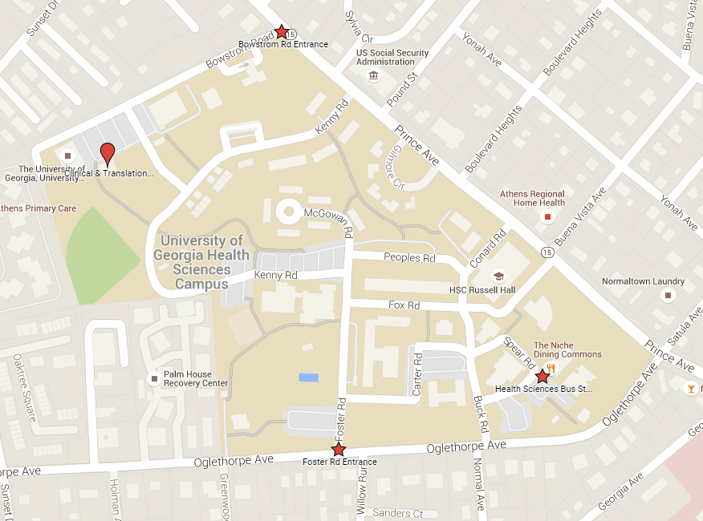
Childcare Center
CTRU

Public Transit Directions:
Both Athens Bus routes 5 and 7 take you to the Health Sciences Campus, but they run in opposite directions. So you might want to check out the Athens Transit website (athenstransit.com) to decide which direction makes the most sense from your starting point. Starting from the multimodal transit center, bus 7 will get you there faster.

On bus 7 you will want to take the Prince Ave at Pound St. stop and cross over Prince Ave to walk down Kenny St.

On bus 5 you will want to take the Prince Ave at Kenny St. stop and walk down Kenny St.

Once on Kenny St. you will cross through the pedestrian gate for the UGA Health Sciences University Housing. You will see a bunch of apartments on your left, follow Kenny St. to the last set of apartments and there will be a cross street on you right. Walk down the cross street and it will drop you in the CTRU parking lot. The CTRU is the building on the left of the lot.

Bus 5 Stop
Bus 7 Stop
CTRU
Childcare Center

